**1.**Write a Python program to count the number 4 in a given list.

def list_count_4(nums):

count = 0

for num in nums:

if num == 4:

count = count + 1

return count

print(list_count_4([1, 4, 6, 7, 4]))

print(list_count_4([1, 4, 6, 4, 7, 4]))

**2.**Write a Python program to test whether a passed letter is a vowel or not.

def is_vowel(char):

all_vowels = 'aeiou'

return char in all_vowels

print(is_vowel('c'))

print(is_vowel('e'))

**3.**Write a Python program to check whether a specified value is contained in a group of values.    
Test Data :  
3 -> [1, 5, 8, 3] : True  
-1 -> [1, 5, 8, 3] : False

def is_group_member(group_data, n):

for value in group_data:

if n == value:

return True

return False

print(is_group_member([1, 5, 8, 3], 3))

print(is_group_member([5, 8, 3], -1))

**4.**Write a Python program to create a histogram from a given list of integers.

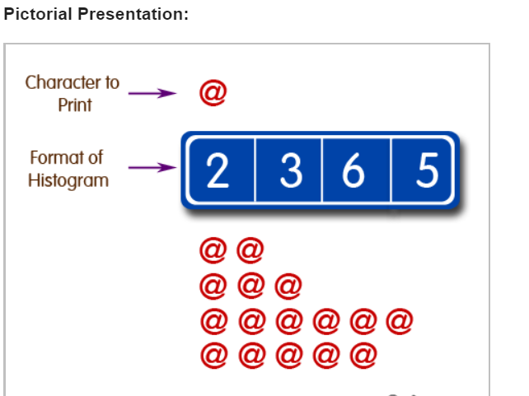

def histogram( items ):

for n in items:

output = ''

times = n

while( times > 0 ):

output += '@'

times = times - 1

print(output)

histogram([2, 3, 6, 5])

5.Write a Python program to concatenate all elements in a list into a string and return it.

def concatenate_list_data(list):

result= ''

for element in list:

result += str(element)

return result

print(concatenate_list_data([1, 5, 12, 2]))

6 Write a Python program that will accept the base and height of a triangle and compute the area.

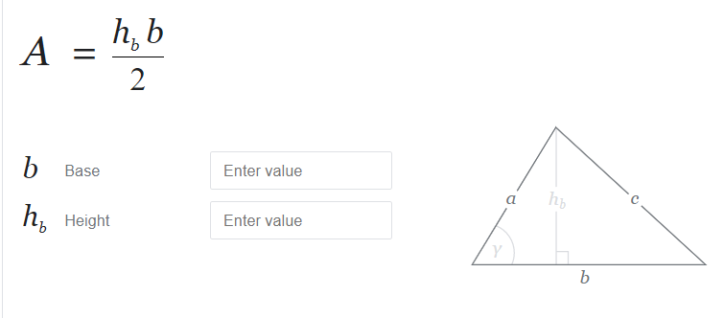

b = int(input("Input the base : "))

h = int(input("Input the height : "))

area = b*h/2

print("area = ", area)

**7.**Write a Python program to sum of three given integers. However, if two values are equal sum will be zero.

def sum(x, y, z):

if x == y or y == z or x==z:

sum = 0

else:

sum = x + y + z

return sum

print(sum(2, 1, 2))

print(sum(3, 2, 2))

print(sum(2, 2, 2))

print(sum(1, 2, 3))

print(sum(5, 4, 3))

**8.**Write a Python program to sum of two given integers. However, if the sum is between 15 to 20 it will return 20.

def sum(x, y):

sum = x + y

if sum in range(15, 20):

return 20

else:

return sum

print(sum(10, 6))

print(sum(10, 2))

print(sum(10, 12))

**9.**Write a Python program that will return true if the two given integer values are equal or their sum or difference is 5.

def test_number5(x, y):

if x == y or abs(x-y) == 5 or (x+y) == 5:

return True

else:

return False

print(test_number5(7, 2))

print(test_number5(3, 2))

print(test_number5(2, 2))

**10.**Write a Python program to compute the distance between the points (x1, y1) and (x2, y2).

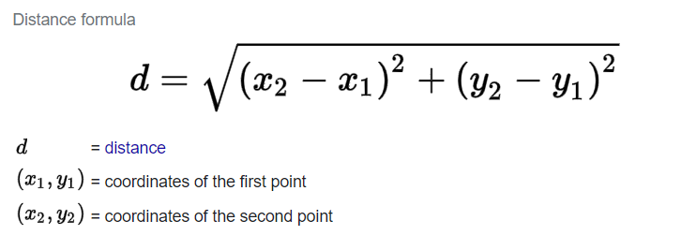

import math

p1 = [4, 0]

p2 = [6, 6]

distance = math.sqrt( ((p1[0]-p2[0])**2)+((p1[1]-p2[1])**2) )

print(distance)